**MenuStrip** control

The **MenuStrip** control represents the container for the menu structure.

The MenuStrip control works as the top-level container for the menu structure. The ToolStripMenuItem class and the ToolStripDropDownMenu class provide the functionalities to create menu items, sub menus and drop-down menus.

The following diagram shows adding a MenuStrip control on the form –

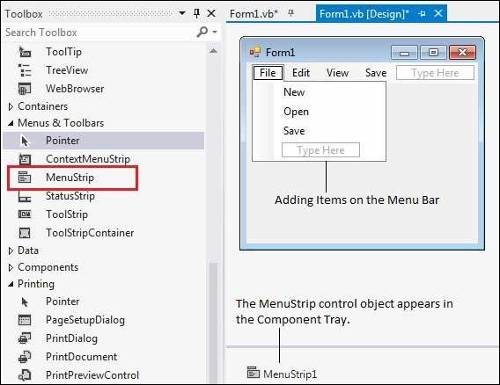

Properties of the MenuStrip Control

The following are some of the commonly used properties of the MenuStrip control −

|  |  |
| --- | --- |
| **Sr.No.** | **Property & Description** |
| 1 | **CanOverflow**  Gets or sets a value indicating whether the MenuStrip supports overflow functionality. |
| 2 | **GripStyle**  Gets or sets the visibility of the grip used to reposition the control. |
| 3 | **MdiWindowListItem**  Gets or sets the ToolStripMenuItem that is used to display a list of Multiple-document interface (MDI) child forms. |
| 4 | **ShowItemToolTips**  Gets or sets a value indicating whether ToolTips are shown for the MenuStrip. |
| 5 | **Stretch**  Gets or sets a value indicating whether the MenuStrip stretches from end to end in its container. |

Events of the MenuStrip Control

The following are some of the commonly used events of the MenuStrip control −

|  |  |
| --- | --- |
| **Sr.No.** | **Event & Description** |
| 1 | **MenuActivate**  Occurs when the user accesses the menu with the keyboard or mouse. |
| 2 | **MenuDeactivate**  Occurs when the MenuStrip is deactivated. |

Example

In this example, let us add menu and sub-menu items.

Take the following steps −

* Drag and drop or double click on a MenuStrip control, to add it to the form.
* Click the Type Here text to open a text box and enter the names of the menu items or sub-menu items you want. When you add a sub-menu, another text box with 'Type Here' text opens below it.
* Complete the menu structure shown in the diagram above.
* Add a sub menu **Exit** under the **File** menu.

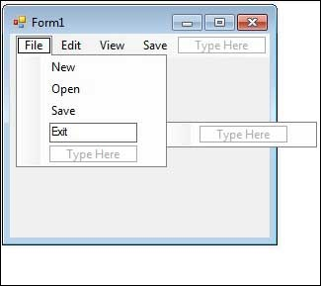

* Double-Click the Exit menu created and add the following code to the **Click** event of **ExitToolStripMenuItem** −

Private Sub ExitToolStripMenuItem_Click(sender As Object, e As EventArgs) _

Handles ExitToolStripMenuItem.Click

End

End Sub

When the above code is executed and run using **Start** button available at the Microsoft Visual Studio tool bar, it will show the following window:

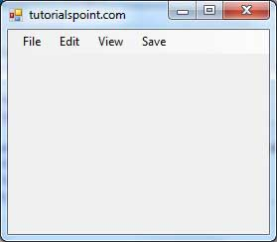

Click on the File -> Exit to exit from the application −

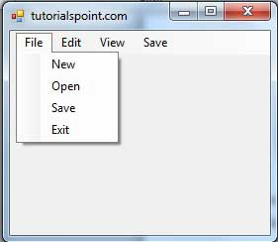

# **VB.Net - Exception Handling**

An exception is a problem that arises during the execution of a program. An exception is a response to an exceptional circumstance that arises while a program is running, such as an attempt to divide by zero.

Exceptions provide a way to transfer control from one part of a program to another. VB.Net exception handling is built upon four keywords - **Try**, **Catch**, **Finally** and **Throw**.

* **Try** − A Try block identifies a block of code for which particular exceptions will be activated. It's followed by one or more Catch blocks.
* **Catch** − A program catches an exception with an exception handler at the place in a program where you want to handle the problem. The Catch keyword indicates the catching of an exception.
* **Finally** − The Finally block is used to execute a given set of statements, whether an exception is thrown or not thrown. For example, if you open a file, it must be closed whether an exception is raised or not.
* **Throw** − A program throws an exception when a problem shows up. This is done using a Throw keyword.

Syntax

Assuming a block will raise an exception, a method catches an exception using a combination of the Try and Catch keywords. A Try/Catch block is placed around the code that might generate an exception. Code within a Try/Catch block is referred to as protected code, and the syntax for using Try/Catch looks like the following −

Try

[ tryStatements ]

[ Exit Try ]

[ Catch [ exception [ As type ] ] [ When expression ]

[ catchStatements ]

[ Exit Try ] ]

[ Catch ... ]

[ Finally

[ finallyStatements ] ]

End Try

You can list down multiple catch statements to catch different type of exceptions in case your try block raises more than one exception in different situations.

Exception Classes in .Net Framework

In the .Net Framework, exceptions are represented by classes. The exception classes in .Net Framework are mainly directly or indirectly derived from the **System.Exception** class. Some of the exception classes derived from the System.Exception class are the **System.ApplicationException** and **System.SystemException** classes.

The **System.ApplicationException** class supports exceptions generated by application programs. So the exceptions defined by the programmers should derive from this class.

The **System.SystemException** class is the base class for all predefined system exception.

The following table provides some of the predefined exception classes derived from the Sytem.SystemException class −

|  |  |
| --- | --- |
| **Exception Class** | **Description** |
| System.IO.IOException | Handles I/O errors. |
| System.IndexOutOfRangeException | Handles errors generated when a method refers to an array index out of range. |
| System.ArrayTypeMismatchException | Handles errors generated when type is mismatched with the array type. |
| System.NullReferenceException | Handles errors generated from deferencing a null object. |
| System.DivideByZeroException | Handles errors generated from dividing a dividend with zero. |
| System.InvalidCastException | Handles errors generated during typecasting. |
| System.OutOfMemoryException | Handles errors generated from insufficient free memory. |
| System.StackOverflowException | Handles errors generated from stack overflow. |

Handling Exceptions

VB.Net provides a structured solution to the exception handling problems in the form of try and catch blocks. Using these blocks the core program statements are separated from the error-handling statements.

These error handling blocks are implemented using the **Try**, **Catch** and **Finally** keywords. Following is an example of throwing an exception when dividing by zero condition occurs −

Module exceptionProg

Sub division(ByVal num1 As Integer, ByVal num2 As Integer)

Dim result As Integer

Try

result = num1 \ num2

Catch e As DivideByZeroException

Console.WriteLine("Exception caught: {0}", e)

Finally

Console.WriteLine("Result: {0}", result)

End Try

End Sub

Sub Main()

division(25, 0)

Console.ReadKey()

End Sub

End Module

When the above code is compiled and executed, it produces the following result −

Exception caught: System.DivideByZeroException: Attempted to divide by zero.

at ...

Result: 0

**Creating User-Defined Exceptions**

You can also define your own exception. User-defined exception classes are derived from the **ApplicationException** class. The following example demonstrates this −

Module exceptionProg

Public Class TempIsZeroException : Inherits ApplicationException

Public Sub New(ByVal message As String)

MyBase.New(message)

End Sub

End Class

Public Class Temperature

Dim temperature As Integer = 0

Sub showTemp()

If (temperature = 0) Then

Throw (New TempIsZeroException("Zero Temperature found"))

Else

Console.WriteLine("Temperature: {0}", temperature)

End If

End Sub

End Class

Sub Main()

Dim temp As Temperature = New Temperature()

Try

temp.showTemp()

Catch e As TempIsZeroException

Console.WriteLine("TempIsZeroException: {0}", e.Message)

End Try

Console.ReadKey()

End Sub

End Module

When the above code is compiled and executed, it produces the following result −

TempIsZeroException: Zero Temperature found

Throwing Objects

You can throw an object if it is either directly or indirectly derived from the System.Exception class.

You can use a throw statement in the catch block to throw the present object as −

Throw [ expression ]

The following program demonstrates this −

Module exceptionProg

Sub Main()

Try

Throw New ApplicationException("A custom exception _ is being thrown here...")

Catch e As Exception

Console.WriteLine(e.Message)

Finally

Console.WriteLine("Now inside the Finally Block")

End Try

Console.ReadKey()

End Sub

End Module

When the above code is compiled and executed, it produces the following result −

A custom exception is being thrown here...

Now inside the Finally Block